**Name:** V Venkata Sri Prasad

**Batch:** Data Engineering

**Date:** 29/01/2024 – (Day 8)

**OOPS:**

**Class and Object:**



**Object:**

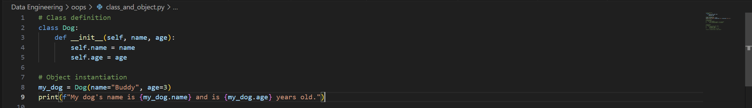



**Access Specifiers:**

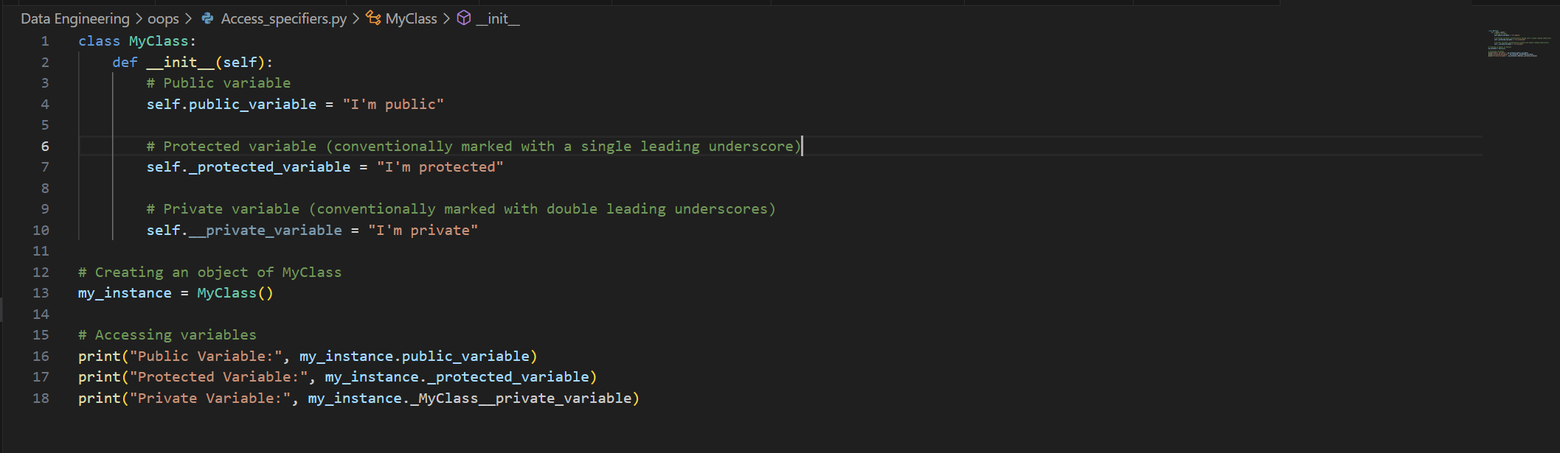

**  
Constructor**

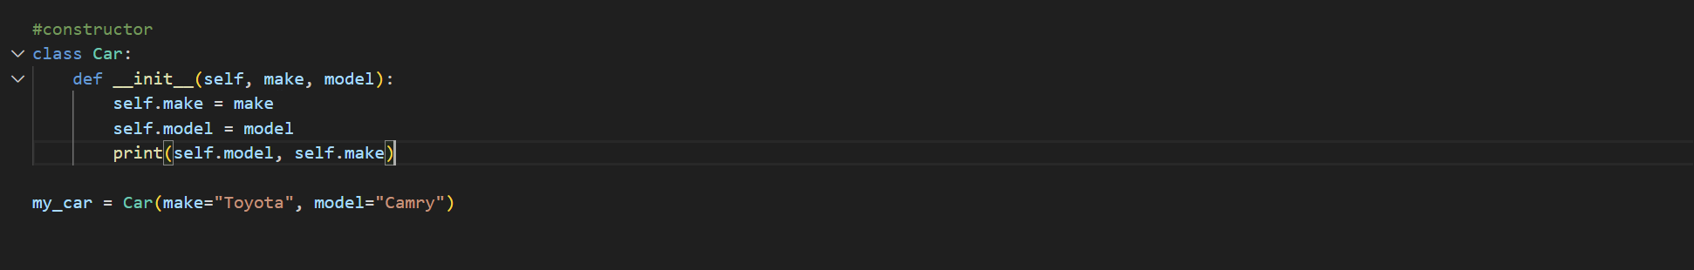



**Inheritance:**

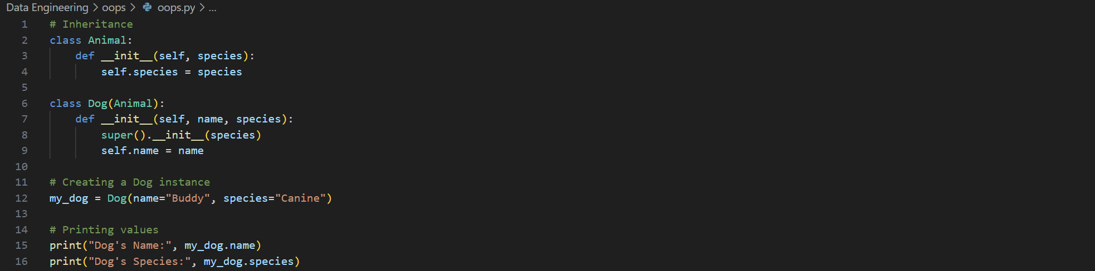



**Polymorphism:**

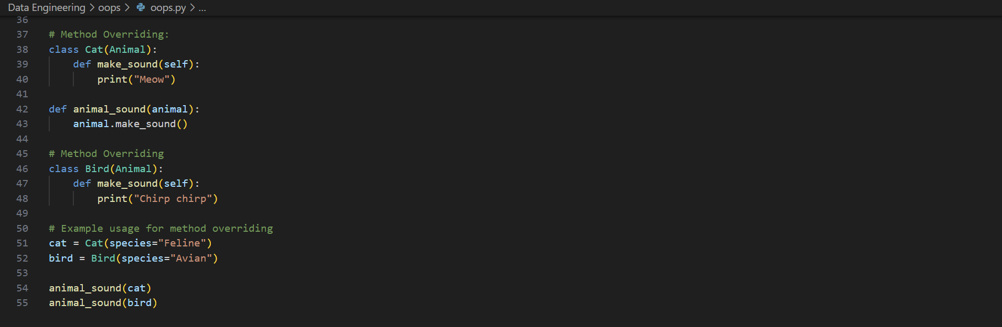

**Method Overloading**

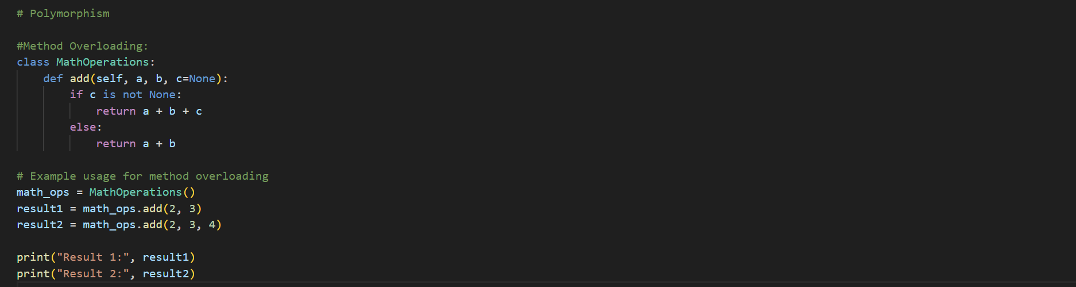



**File handling**

**Read**

**Write**

**Append**

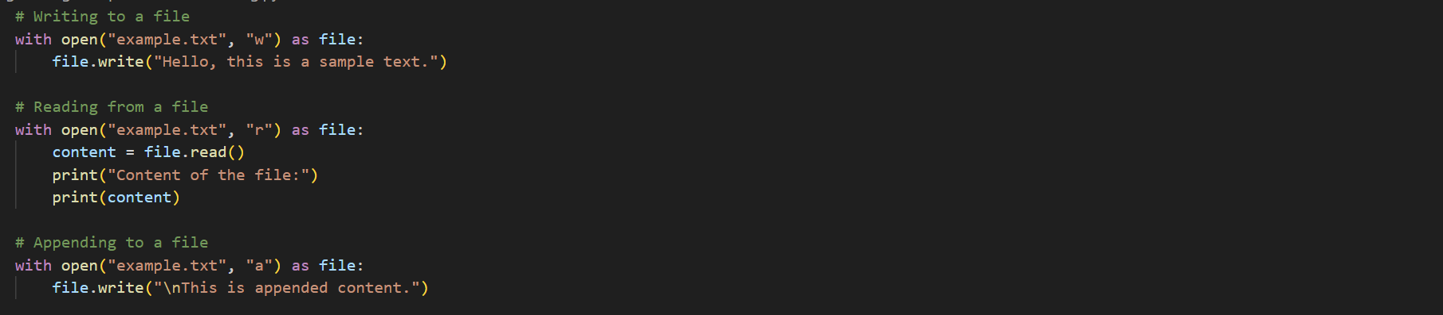

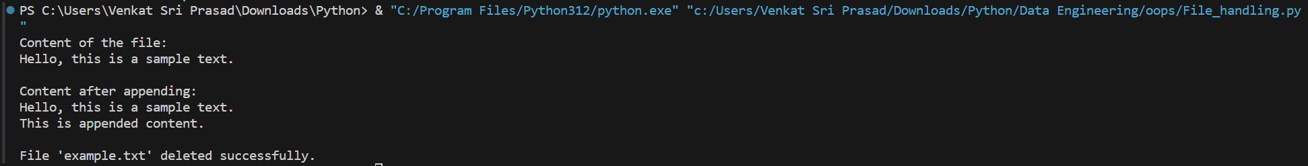

**ReadLine**

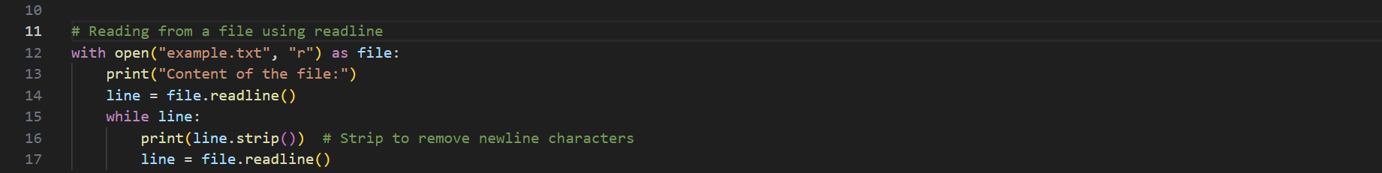



**Delete**

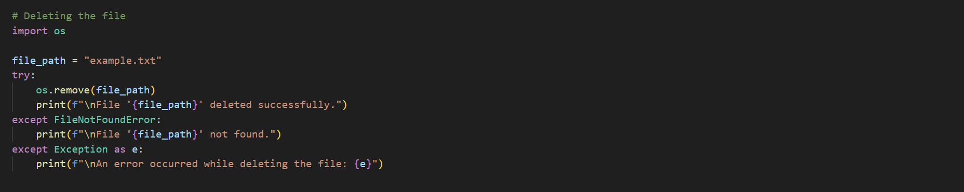



**Exception Handling:**

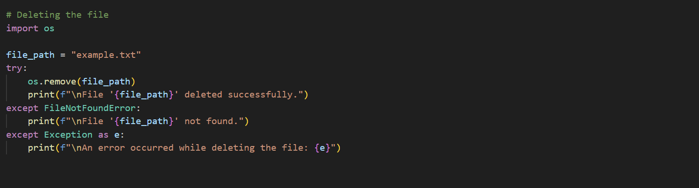

**Modules & Package:**

**Creating a Module name**

**Example Module:**



**Importing module in main module:**

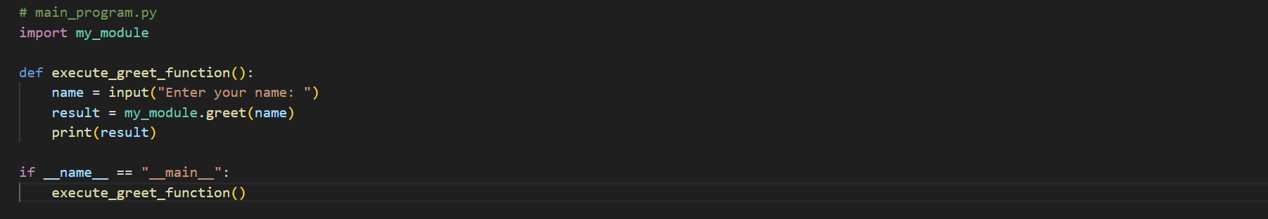



**Importing * and writing a function**

